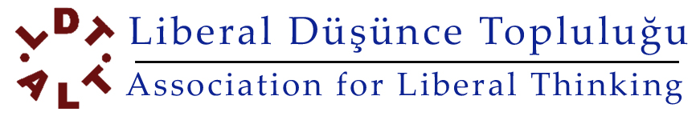
GMK Bulvarı No: 108 / 17 Maltepe, Ankara, 06570 Turkey www.liberal.org.tr
Phone: + 90 312 231 6069 – 231 1185 Fax: + 90 312 230 8003 e-mail: info@liberal.org.tr

Regular Donation Order via Credit Card

This form should be filled out by the owner of the credit card!

Owner of the Credit Card
(Name & Family name / Full name on the card)
Credit Card Number
Valid Thru
CVV2 / CVC2
(Last three numbers on signature strip)
Bank Name
Credit Card Type
(Visa – Mastercard)
Amount ($) (£) (€) – in figures
Amount ($) (£) (€) – in words
Which day of the month would you like us to draw the amount?
E-mail Address
Mailing Address
Mobile Phone Number

I hereby approve that Association for Liberal Thinking is authorized to collect the amount written in figures and words above every month.
Date :

Signature :

Please fill out this form in typewriting and sign it. Fax it to + 90 312 2308003 or scan and email it to info@liberal.org.tr .

